Game Design Document

Fill up the Following document

1. Write the title of your project.

Escape The Maze

1. What is the goal of the game?

To escape the maze by clearing 3 different levels without bumping into a guard.

1. Write a brief story of your game?

Once there was one man named steve who buyed this wierd game called escape the maze

But did’t realize it was just a tricky trap. As soon as he opened the game he entered it and got trapped. Now he has to escape it by solving three levels and by dodging guards controlled by computer. He needs the help of player to escape it.

1. Which are the playing characters of this game?

* Playing characters are the ones which respond to the user based on the input from the user
* Cars, monkeys, dinos, wizards etc, are the playing characters in the game.

|  |  |  |
| --- | --- | --- |
| Number | Character Name | What can this character do? |
| 1 | ***Steve*** | He escapes the maze”s different levels |
| 2 |  |  |
| 3 |  |  |
| 4 |  |  |
| 5 |  |  |
| 6 |  |  |
| 7 |  |  |
| 8 |  |  |

1. Which are the Non Playing Characters of this game?

* Non Playing characters are the ones which don't have an action or a behaviour when the user interacts with the game.
* Hurdles, stones, bananas, coins, etc are non playing characters in the game.

|  |  |  |
| --- | --- | --- |
| Number | Character Name | What can this character do? |
| 1 | Guards | They patrol around the level’s maze and try to capture steve by bumping into him |
| 2 |  |  |
| 3 |  |  |
| 4 |  |  |
| 5 |  |  |
| 6 |  |  |
| 7 |  |  |
| 8 |  |  |

Draw your imagination of this game. What does this game look like?

* Draw the game either on your computer or on paper,
* Add images of scenes of the game to show each of the playing and non-playing characters at least once.

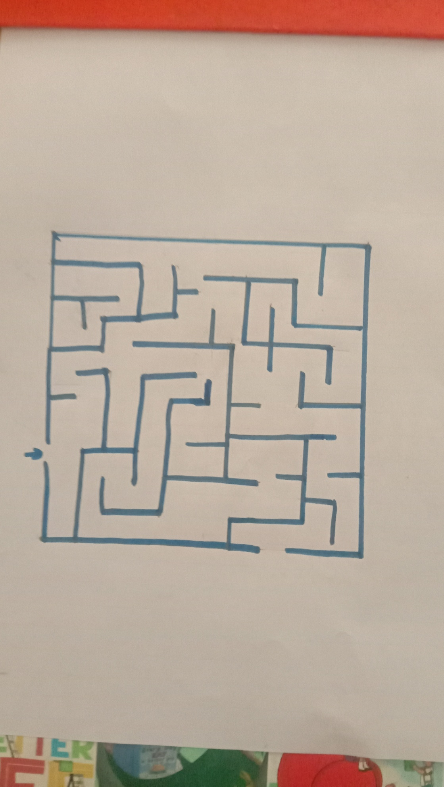

How do you plan to make your game engaging?

1. The player can only move using arrow keys.
2. To clear the level you need to finish the maze and come to a certain point.
3. If he bumps into a guard he will have to restart the level.
4. He will have only 3 chances if he bumps into a guard he will lose 1 life.
5. If he loses all lives he will have to restart all over again.
6. The player will get 3 hearts displayed on top left of the screen in which if he bumps into a guard he will lose one of them.
7. If he loses all of them he will have to restart the whole game and it will be displayed GAME OVER.
8. Then when he enters level 1 it will be displayed level 1 like that it will be displayed in other levels also.
9. One it is game over he will get a restart button on bottom left.